**CHKN-92 – Research naming for output variables**

* Was still a little confused as to what I was doing here and should have asked for clarity sooner so this might need a little refinement/clarity

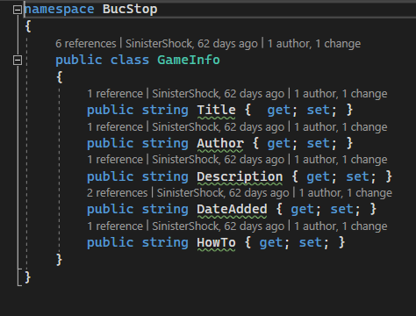

* This is what we currently have for under the MicroServices/GameInfo.cs folder.
* Some guidelines for naming future output variable for microservices: <https://softwareengineering.stackexchange.com/questions/402143/what-is-the-best-practice-when-it-comes-to-naming-microservice-endpoints>
* Couldn’t find a lot of content on this. Basically, be consistent and choose clear names. I didn’t find any other clear guidelines.